IMG_256

### **[点微]微信平台**

Discuz 论坛微信运营首选平台

**TOM微信运营平台组件升级方法**

**第一步：打开**[http://addon.discuz.com/?@tom\_weixin.plugin](http://addon.discuz.com/?@tom_weixin.plugin" \t "http://www.tomwx.cn/_blank)**找到扩展组件菜单选择要升级的组件**

[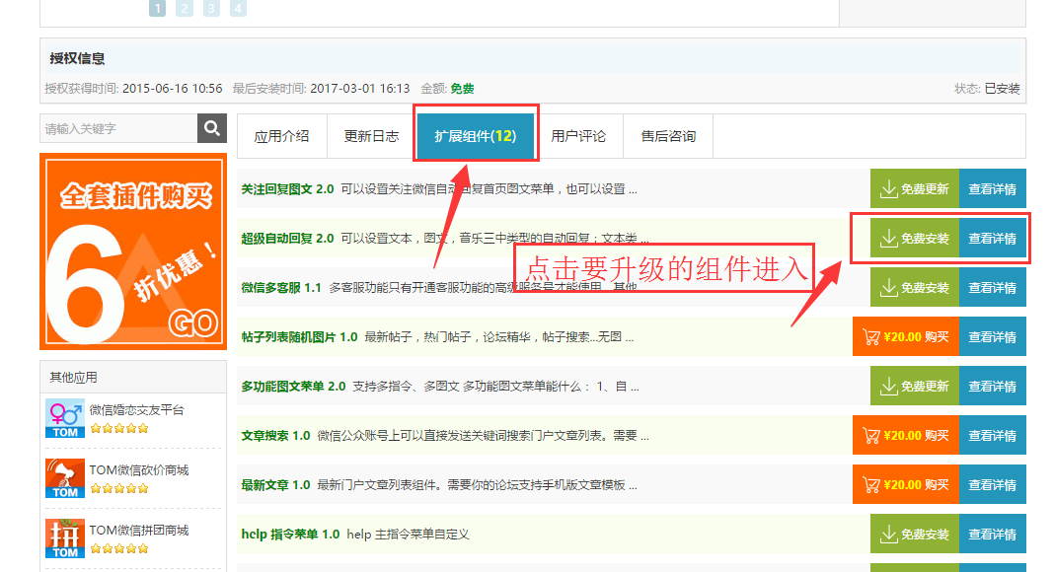](http://www.tomwx.cn/source/plugin/tom_editor/editor/attached/image/20170301/20170301091507_10319.png)

[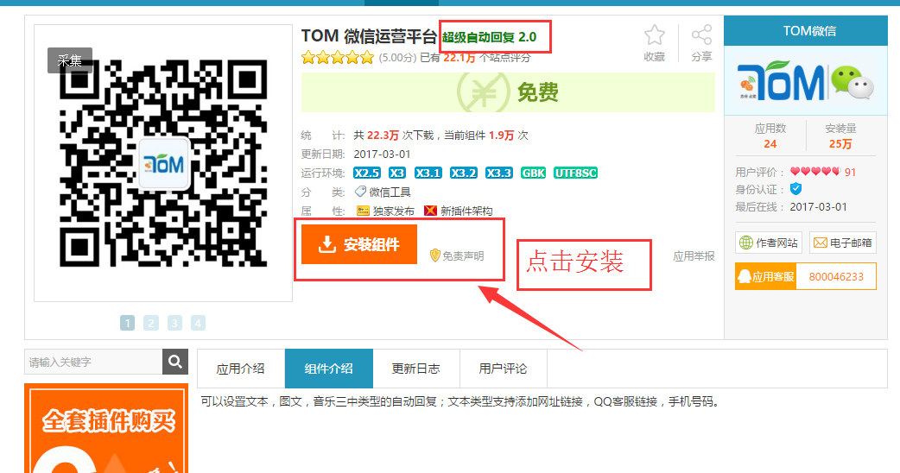](http://www.tomwx.cn/source/plugin/tom_editor/editor/attached/image/20170301/20170301091523_66400.png)

**第二步：TOM微信运营平台后台 》组件管理 》升级**

[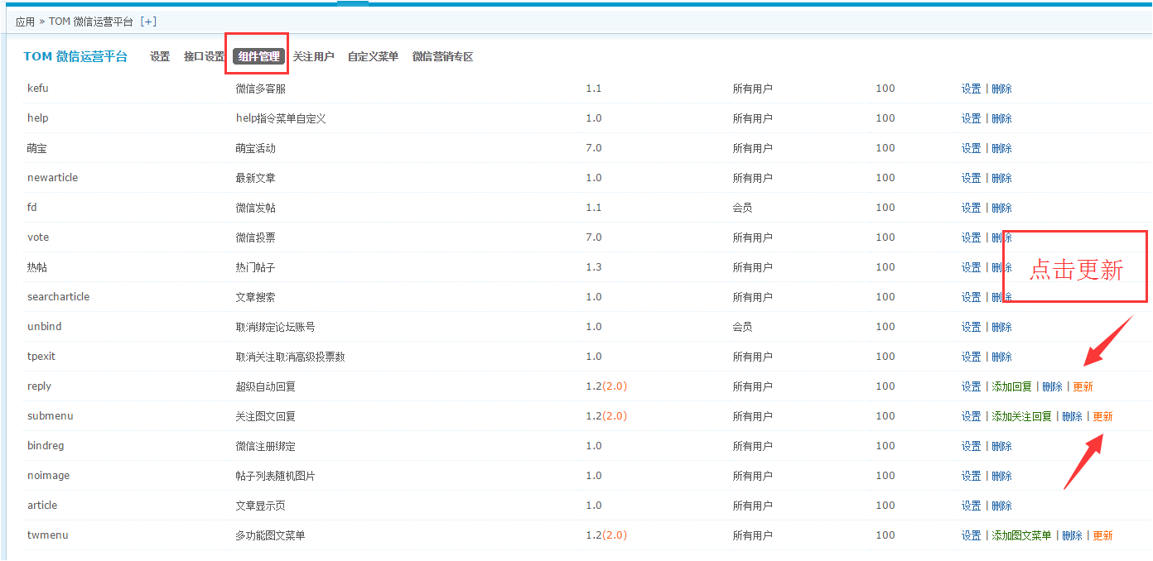](http://www.tomwx.cn/source/plugin/tom_editor/editor/attached/image/20170302/20170302012649_62061.png)